**Sardar Vallabhbhai National Institute of Technology, SVNIT**

**Department of Computer Science and Engineering**

No. CSE/MTech/22-23. Date: / /2023

**Submitted for Approval**

**Subject:**  Regarding MTech Contingency Approval.

I, Nihar Sodhaparmar, admission number (P22CS013) full-time MTech student of the Computer Science and Engineering Department, request your kind consideration and approval for the purchase of the items below under the MTech Contingency fund. The details of the items and prices are attached hereby.

| Sr. No | Description | Amazon | Flipkart | Croma | Qty | Approximate Cost |
| --- | --- | --- | --- | --- | --- | --- |
| 1 | Western Digital WD 1TB My Passport Portable Hard Disk Drive, USB 3.0 with Automatic Backup, 256 Bit AES Hardware Encryption,Password Protection,Compatible with Windows and Mac, External HDD-Black | ₹ 4449 | ₹ 4449 | ₹ 4449 | 1 | ₹ 4449 |
| 2 | SanDisk Ultra 64 GB USB 3.0 Pen Drive (SDCZ48-064G-135/SDCZ48-064G-UAM46, Black) | ₹ 459 | ₹ 712 | - | 1 | ₹ 459 |
| Total Approx. Cost | | | | | | ₹ 4908 |

Thereby, kindly grant the approval to use the contingency fund for purchasing the items mentioned in the above table. Hoping for your positive response.

Thanking You,

Nihar Sodhaparmar

(P22CS013 MTech 1st year)

R. P .Gohil Dr. Rupa G. Mehta Dr. Ravi Kant

(PG Incharge) (HoD, CSE) Dean (Student Welfare)

* **Amazon**

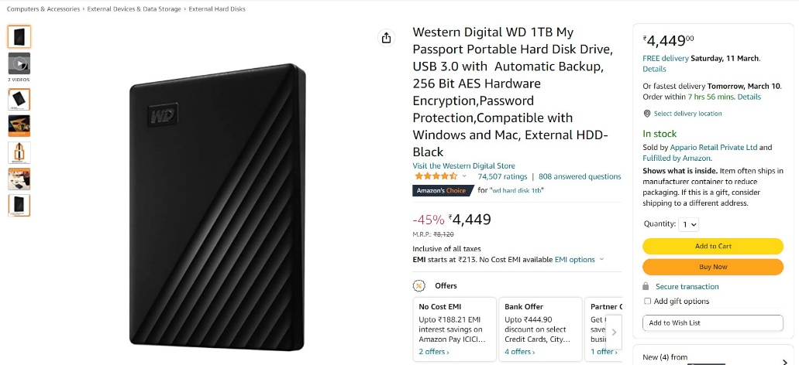

* **Flipkart**

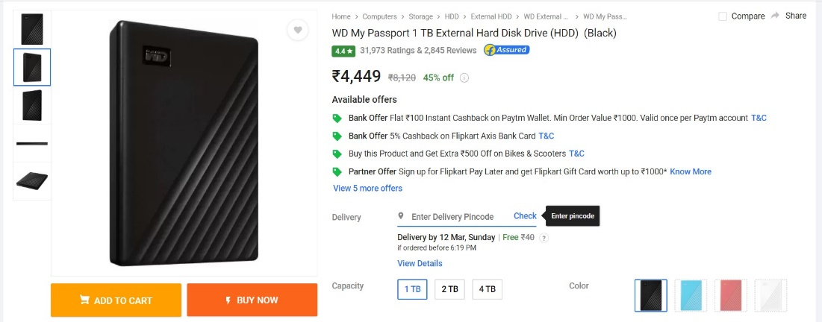

* **Croma**

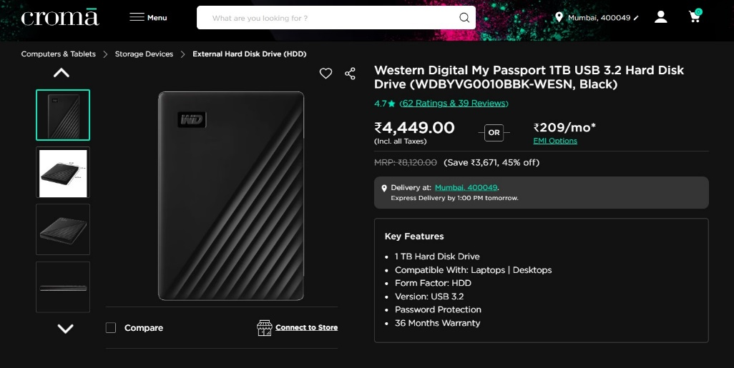

* **Amazon**

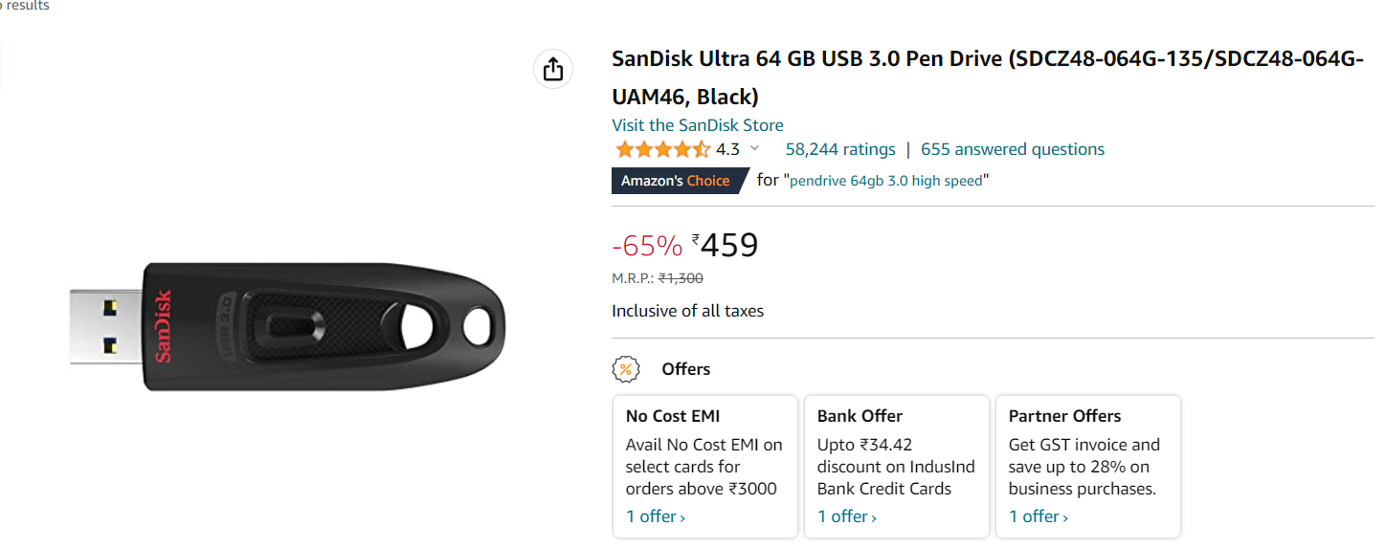

* **Flipkart**

